05 | Updated User Stories and Product Backlog
  - Revised acceptance criteria and the SIS 10–11 ClickUp task snapshot
PROJECT SafeStep | Deliverable 5 | 11 November 2026
TEAM Zhumabay Dias · Temirlan Satybaldy · Beknur Ualikhanuly · Sagidolla Beibars · Saparbek Bekzat
STATUS / SCOPE: Story/backlog identifiers here are local to the SIS 10–11 report. User-story requirements are distinct from claims of complete browser verification.

1. Baseline product stories inherited from earlier coursework
ID | User need | Priority
US-1 | Automatically hold risky payments before money leaves the account. | Must Have
US-2 | Allow a customer to complete simulated trusted-device step-up. | Must Have
US-3 | Allow an operator to resolve a held legitimate payment with a recorded reason. | Must Have
US-4 | Provide multilingual fraud warning text. | Must Have
US-5 | Record and export an explainable audit trail. | Should Have
US-6 | Support risk-threshold/hold-duration configuration. | Should Have
US-7 | Prepare incidents for future National Anti-Fraud Center sharing via mock outbox. | Could Have

2. Updated improvement stories

P2-US-01 | Explicit operator reason
As a contact-centre operator, I want to enter my own reason before releasing or cancelling a held payment so that the audit trail records the explanation I actually supplied.
- Reject blank and whitespace-only reasons in the UI and direct API (HTTP 422).
- Invalid reason must not alter payment, audit or incident data.
- Accept nonblank release/cancel reasons and store the trimmed text.
- Never substitute a predefined phone-call/fraud-confirmation message.
- Display Russian and Kazakh validation labels/messages.
State: Implemented and verified to the limited scope described in Part 2.

P2-US-02 | Warning request recovery
As a customer viewing a held payment, I want to see an error and a Retry option if warning information cannot load so that I can continue after service recovery.
- Show localized error instead of indefinitely loading or silently presenting stale warning.
- Retry sends a warning GET request but does not submit a payment decision.
- Warning content and controls return after backend recovery.
- Ignore superseded request results; Russian and Kazakh messages are implemented.
State: Implemented. Manual Kazakh error/recovery evidence collected; no full automated browser concurrency check.

CR01-US01 | Search and filter payments
As a contact-centre operator, I want to find payments using the beginning of a customer ID or payee and filter by status so that I can locate relevant records without scanning the entire queue.
- Match customer_id OR entire payee field using case-insensitive startsWith; trim surrounding query spaces.
- aig/AIG match aigerim; ge/rim do not; KZ12 matches KZ12 Mother; Mother/Z12 do not.
- Status choices: All, Held, Sent, Released, Cancelled; initial choice Held.
- Combine text and status conditions; Clear Filters returns empty query + All.
- Display match/total count and localized no-results state.
- Retain selections during polling and preserve decision/audit controls.
State: Implemented. Fourteen filtering logic tests pass; screenshots demonstrate key search/filter cases.

3. SIS 10–11 ClickUp backlog snapshot
Task | Work package | ClickUp status
P1-01 | Test Existing SafeStep Features | Done
P1-02 | Prepare and Prioritize Issue Log | Done
P1-03 | Document Technical Debt | Done
P2-01 | Require Operator Decision Reason | Done
P2-02 | Implement Warning Error and Retry | Done
P2-03 | Collect Before and After Evidence | Review
P3-01 | Prepare Client Change Request CR-01 | Done
P3-02 | Complete Change Impact Analysis | Done
P4-01 | Implement Payment Prefix Search and Filters | Done
P4-02 | Run New Feature Tests | Done
P4-03 | Attach New Feature Screenshots | Review
P5-01 | Prepare Commercial Offer | Review
P5-02 | Prepare Fixed-Price Contract | Review
DOC-01 | Update Product Backlog and Acceptance Criteria | To Do
DOC-02 | Attach Evidence and Capture Final Board | To Do
FINAL-01 | Prepare 10-Minute SIS 10–11 Presentation | To Do

Snapshot from the uploaded ClickUp Board screenshot: 9 Done, 4 Review, 3 To Do. Task assignees in ClickUp are administrative assignments; this report does not independently verify who performed each code change. Since the screenshot, final documents and presentation have been drafted in this conversation; refresh actual board statuses only after review/attachments.
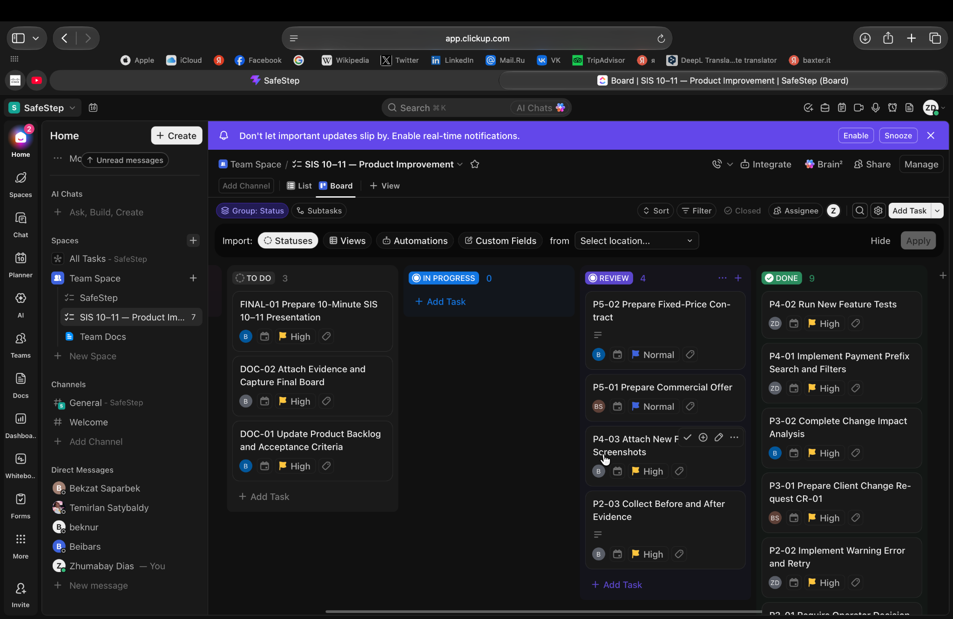
Figure 1. User-provided SIS 10–11 ClickUp task board (9 Done / 4 Review / 3 To Do).

4. Deferred and future backlog items
Backlog | State | Reason
PB-P2-05 — Completed-payment state guard | Deferred / Open | ISS-03 needs mutation prevention and regression tests.
PB-SEC-01 — Authentication + device proof | Open | ISS-01 and ISS-02 remain production blockers.
PB-SEC-02 — Dependency triage | Open | ISS-05 audit findings require analysis.
CR01-PB7 — Server-side search + pagination | Future | Only useful if data volume makes frontend filtering unsuitable.

